OPERATION ACTIVE RESOLVE

SPECIAL OPERATIONS COMPONENT COMMANDER

INTELLIGENCE REPORT D6

# General Information

This intelligence report covers the last 24 hours (from SOCC units and intelligence from D6).

# Intelligence

## SYTGT003 – 922nd SCUD Regiment base

* NSTR

## SYTGT137 South Aleppo Rocket Fuel Factory

* During the last 24 hours, activity have increased in the factory. No vehicles are seen arriving or leaving the area.

## SYTGT056 – Port Tartus

During D6 the team have identified 1 unknown submarine coming into port. It stayed in port for about 12 hours before going back out to sea.

**ASSESSMENT:** LIKELY refueling and replenishment. Possible crew change.

The tree ships identified on D4 is still in port, but activity in vicinity of all ships have increased the last 24 hours.

**Overview ships Port Tartus:**

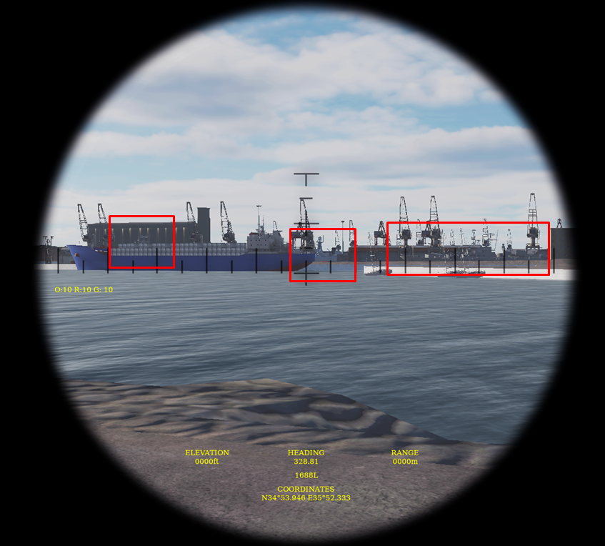

**Ship 1:**

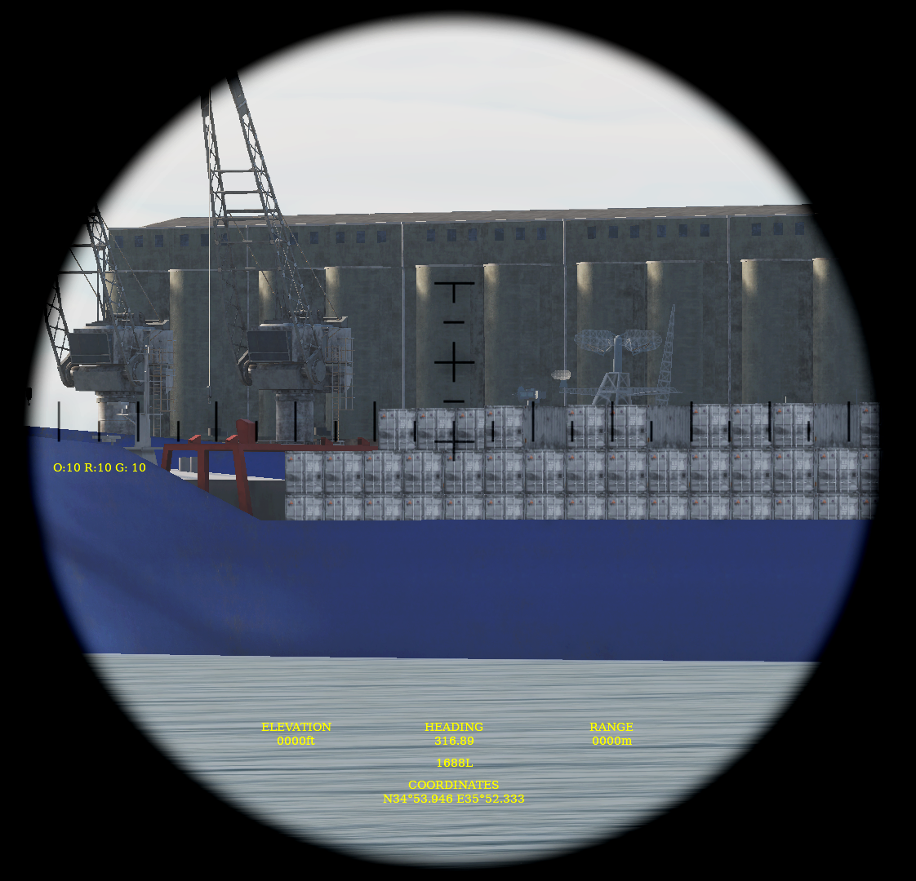

**Ship 2:**

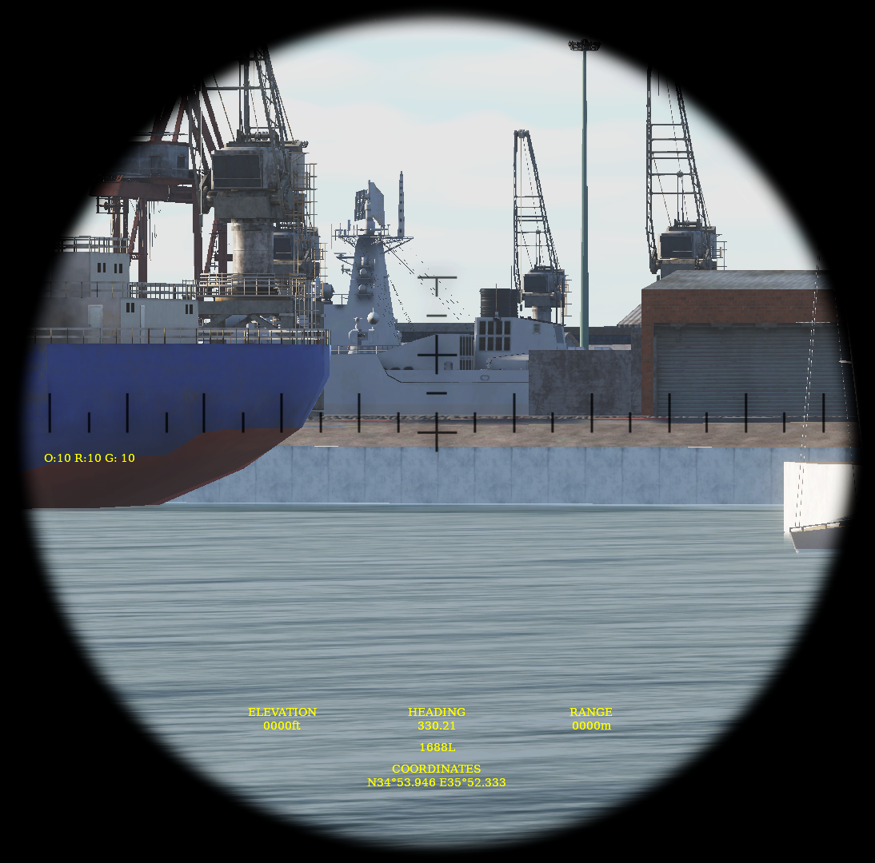

**Ship 3:**

